October Snack & Activity Calendar
2020
Mission Focus: Homemade Dog Treats for Shelter | Creation Station: Zacchaeus continues…

Sunday | Monday | Tuesday | Wednesday | Thursday | Friday | Saturday
 |  |  |  | 1 | 2
 |  |  |  | Bananas and Boo Berry Cereal | Teddy Bear Picnic  Bring a Bear to school today
4 | 5 | 6 | 7 | 8 | 9 | 10
Letter “C”  Week | Cinnamon Toast Crunch Cereal  Tuition Due | Carrots, Cucumbers and Celery | Car jello  Lunch Bunch Starts  TODAY!!! | Cantaloupe and Crackers | No School  Revere NEO Day | Chapel with Pastor Bill every Wednesday 9:15am
11 | 12 | 13 | 14 | 15 | 16 | 17
Letter “D”  Week | Dog Fruit snacks | Dip and Vegetables | Dog Day  Dog Bones | Dinosaur Jello | Book Orders due online  Dirt Cups | Lunch Bunch every Monday and Wednesday  11:30- 1:00pm  $6.00 per day
18  Letter “E”  Week | 19  Green Eggs And Ham | 20  Muffins with EYEs | 21  Eggplant Fries  Towels for Dog Shelter due today | 22  Edamame | 23  Egg Rolls  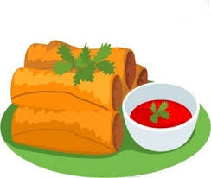 | 24  100% fruit juice served & fruit alternative
25  Letter “F”  Week | 26  Farfalle Pasta | 27  Fruit Loop  Cereal | 28  Fig Newton  Cookies | 29  Fish Crackers | 30  Harvest Party  10:00am FFC | 31  